Step 3: Connect to Twitter from Python using Twython

If you don't already have a Twitter account, you'll need to create one at [twitter.com](https://twitter.com/signup)

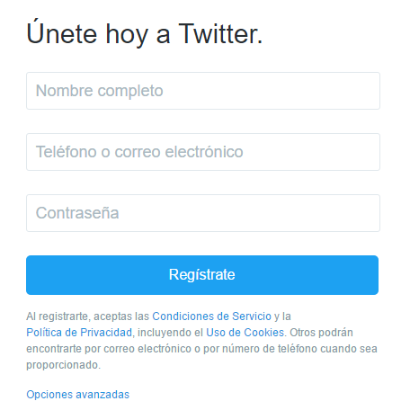

After you sign up, you have a Twitter account:



To access the Twitter account from Python using the Twitter API:

1. Go to [apps.twitter.com](https://apps.twitter.com/) and click the Create New App button:
2. Complete the application details form.

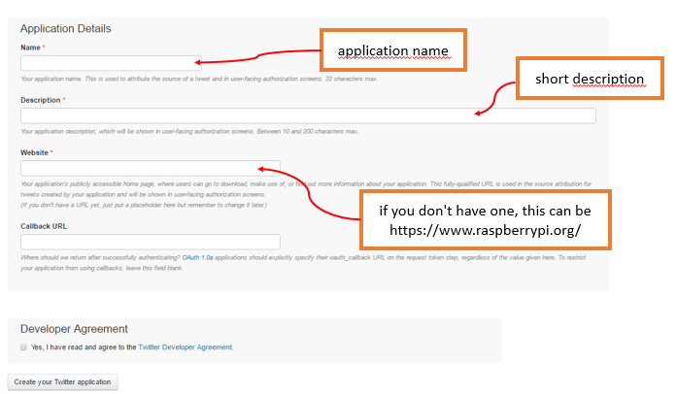

1. Modify your app permissions from Read only to **Read and write**.
2. Click the 'Keys and Access Tokens' tab and create an access token. Refresh the page and you'll see a new section with your access token details.
3. You should now be able to see your Consumer key, Consumer secret, Access token, and Access token secret.
4. Very important, check that the system time of your raspberry Pi is correct, because otherwise Python Will not connect to Twitter.

Open a terminal window and enter the following command:

**sudo raspi-config**

If the date/time is still wrong, enter with the current time and date:

**sudo date -s "**2 Feb 2017 00:00:00**"**

Now Open Python 3, create a new file and paste your API keys:

consumer_key = ''

consumer_secret = ''

access_token = ''

access_token_secret = ''

Save the file as auth.py, create another new file:

from twython import Twython

from auth import (

consumer_key,

consumer_secret,

access_token,

access_token_secret

)

twitter = Twython(

consumer_key,

consumer_secret,

access_token,

access_token_secret

)

Now, you can to send a tweet:

message = "Hello!"

twitter.update_status(status=message)

Save the file as .py and run From Python text editor or from the terminal window.

|  |
| --- |
|  |
|  |  |
|  |  |
|  |  |
|  |  |
|  |  |
|  |  |
|  |  |
|  |  |
|  |  |
|  |  |
|  |  |
|  |  |
|  |  |